Denavit-Hartenbergh Solution notation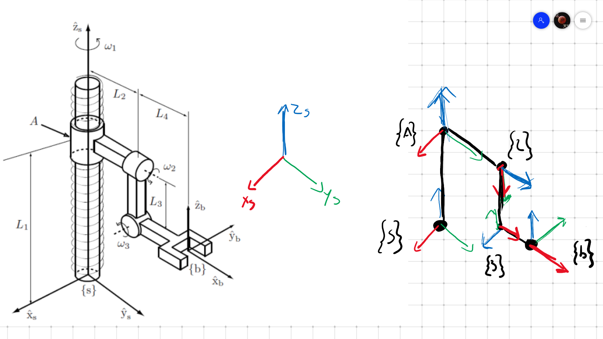

The 4-variable notation for every joint becomes

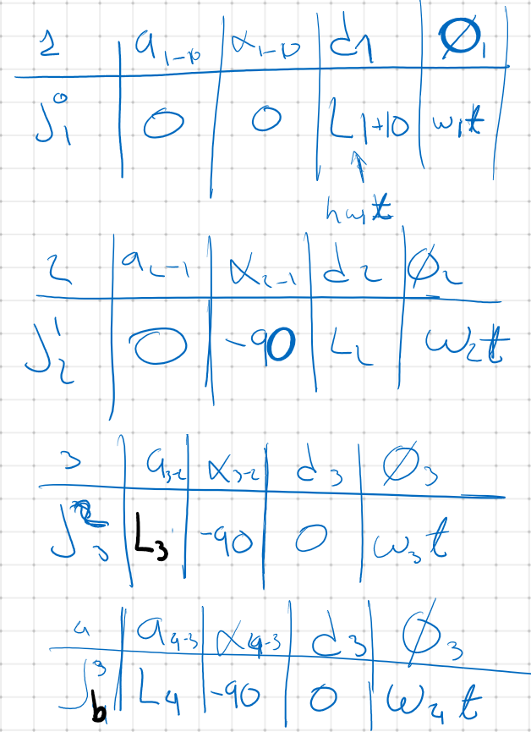



W is the constant angular velocity of the given joint

t is the time step over which we calculate

h is the pitch of the lead screw

The general D-H homogeneous transformation matrix is:

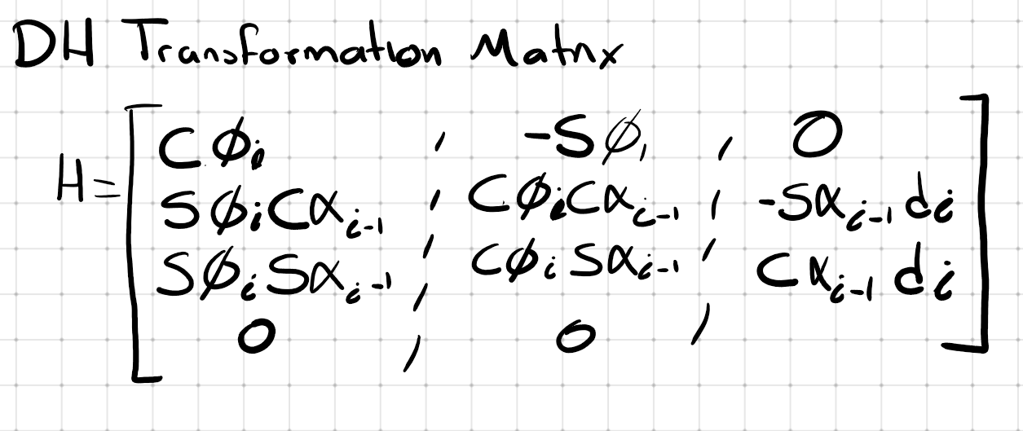

Where C represents the Cosine of the following angle, S represents the sine of the following angle. Filling for the matrix 4 times with each of the joint parameters gives the matrix transformation for each of the 4 joints. Remembering that sind(-90)=-1, sind(90)=1, sind(0)=0, cosd(90)=0, cosd(-90)=0,

Multiply so {b}=DH1*DH2*DH3*DH4 to get the homogeneous transformation from {S} to {b}. if t is the time step of increment t and you have n many steps, you will have n many DH results. This is only valid because the angular speed of every joint is constant

**THERE ARE OTHER WAYS TO SOLVE THIS USING THE SAME ASUMPTION OF:**

Angle=Angular Velocity x time step

**THAT ALLOW TO SOLVE THE PROBLEM USING EULER ROTATIONS AND SIMPLELINEAR TRANSLATIONS**

The solution using Euler geometry for the translation and rotation is as follows



Then the homogeneous transformation becomes the concatenation of every Eulean transformation for every joint of the following form

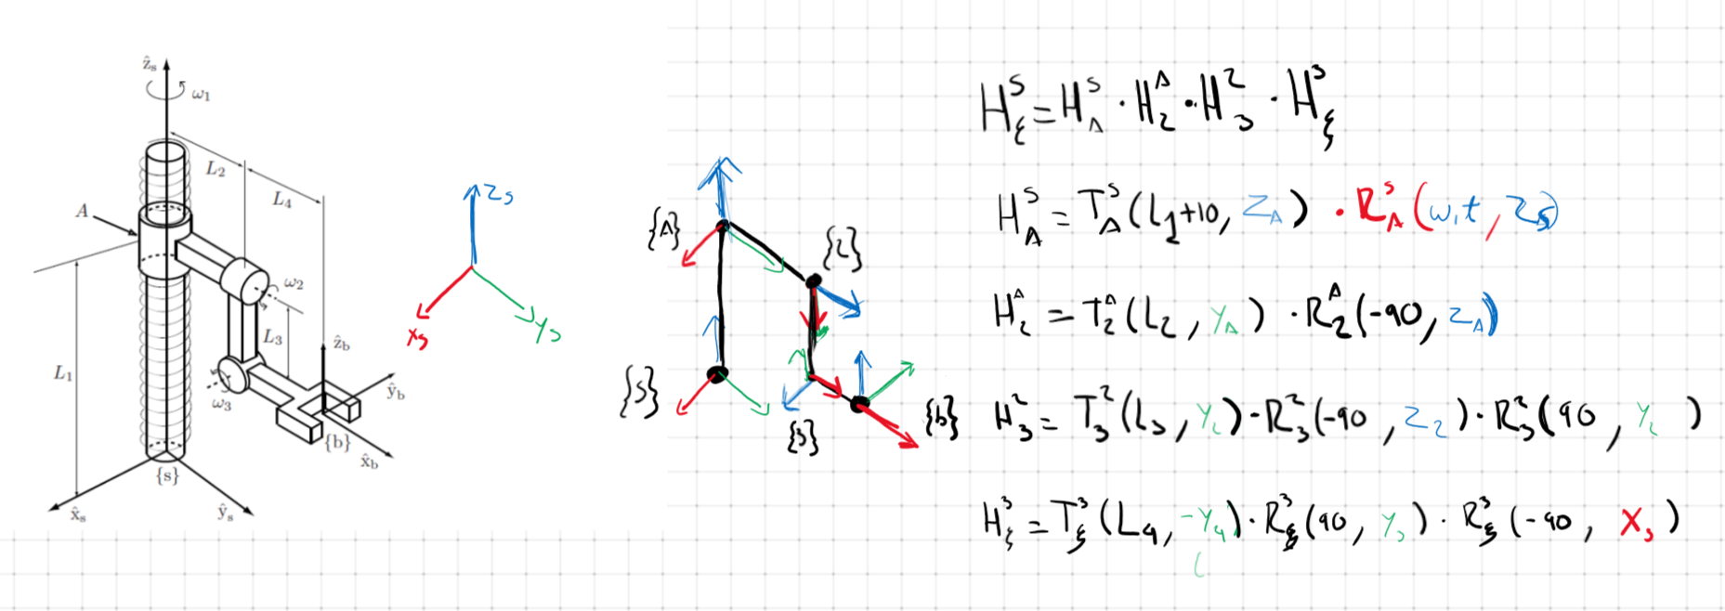

Where

